‏

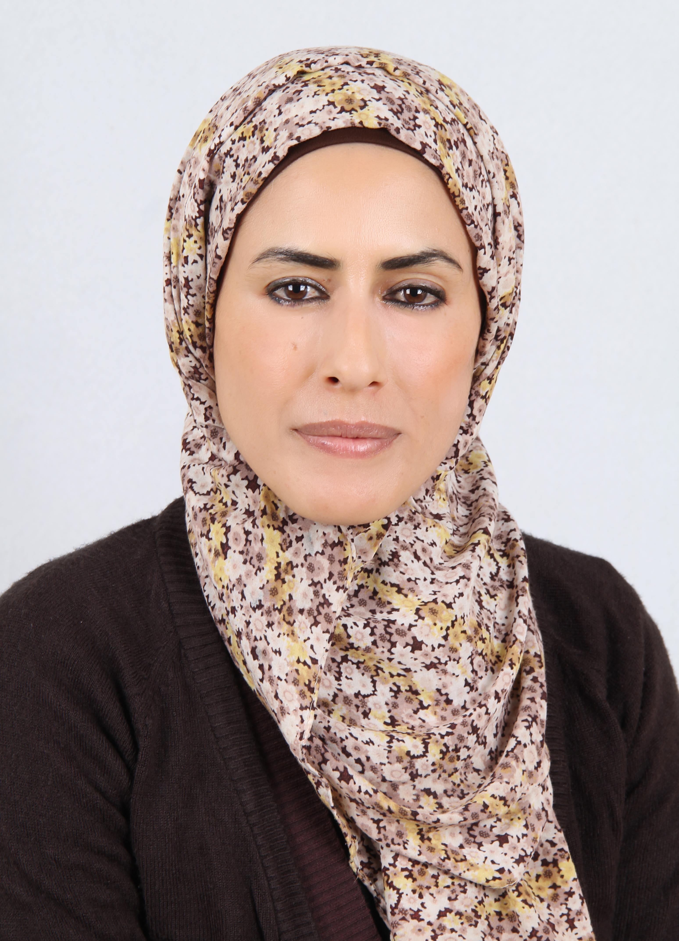

Aydah Abu-tayeh, (Phd)
Mobile :+962796498531
E-Mail: Aydah.abutayeh@ahu.edu.jo
aydah1995@yahoo.com

-Nationality: Jordanian
-Position: Researcher at Al Hussein bin Talal university.
-Education:
Bachelor: Sociology , Master: Social Work/ Jordan University
PHD in Sociology/Criminology/ Mutah University.

* Teaching -Civil Education

* experience in work

• Counseling in high school( 2001-2008 ) .
• Working in woman section department in Al – Hussein Bin Talal University (28/2/200 – 7/9/2010) .
• Preparing and presenting radio programmes about the woman , social issues and the news of woman in Sout Al Janoub radio station from 2008- present
- Preparing and presenting T.V programmes about the woman , and youth social issues in Television production studio in Center for Studies, Consultation and Community Development in Al – Hussein Bin Talal University from 2012 until now.
- Writing Proposals for small Project.
- Head of the "Women network for development" a women project from 2008- 2016, a winning project the best media production on women of the Arab Women's Organization in 2012 in Algeria Award for a documentary film produced by the Jordanian TV.
- Working as academic researcher in the Studies and Development Center & in Princess Basma Center for the intangible Heritage.2009- 2017
- director of princess basma for intangible cultural heritage. 2017- till present.

* academic publication

- Community organization in al- jafer (case study) research. Journal of the education and psychology ,Ain Shams University, No 37 ,(1),pp 841-859.

- Social justice in Jordan (gender gap Perspective) reality and indicators. Journal of the Faculty of Education-Ain Shams University, Vol 19,No 1,pp 65-87

- Hunting culture anthropological study of the methods of Falconry in Al-jaffer Badia in southern Jordan (the principal researcher) Al-Hussein Bin Talal's Journal of Research, Vol 1, Issue 4 /2016

- Popular Religious and cultural Practices: Anthropological paper about Petra Community (The second researcher). Studies and Research. An International Refereed Journal ZianeAchour, University Djelfa,Issue(22) / Feb 2016

- Widows and divorcees \ properties in the Governorates of South Jordan and the problems they face).Studies and Research. An International Refereed Journal ZianeAchour ,University Djelfa, Issue (23) /2016. Pp292-307.

- Trends citizens in Maan to developmental impact of Al-Hussein Bin Talal University (1999-2014). (in print). Al-Hussein Bin Talal's Journal of Research, Vol 1, Issue 4 /2016.

- Trends Jordanian citizens toward women's social and economic and political rights in Governorate of Karak, tafela. maan .(group of researchers) International Journal of Humanities and Social Science Vol. 7, No. 4; April 2017.

- folk medicine in the governorate of Maan: the social representations and forms of practice (2017), Dirassat and Abhath (Research and Studies Journal) The Arabic Journal of Human and Social Sciences, No. 28,p:115-131.

- social and economic reality of Al-Mariaga district "developmental approach" 2018, Jordan Journal of Social Sciences, Vol.11,No.1,p:148-163.

- The Youth: Values and Attitudes: A Survey Administered on Students at AlHussein Bin Talal University, 2018, Canadian Social Science, Vol. 14, No. 6, pp. 1-12.

experiences and training

Training of Trainers courses:
- Certifed Dialogue Education Partitioners, 2018 account link: http://globallearningpartners.com/about/our-team/cdep/aydah-mhagir-abutayeh

- Inter Action Training Programme: Leadership in community Development Project( LICD), British Council (Dec.2008 to Mar 2009).

- Active citizen training of trainers programme ( British Council / seeds organization) TOT 2011/2012.

- Youth councils project (TOT) 2014/2015 Al- qantara center for human resources development.

- passport to success PTS ( TOT) International youth foundation / 2015.

training works

- (gender issue) for youth with Higher Population Council & JICA Jordan in some area in maan and aqaba (2009) .

- youth for future ( to encourage youth and their parents to get the job without interest of shame culture, 2010) with youth organization programme .

- training with Injaz organization. (I training many courses with them, 2008/2011/2015).

- trainer in active citizen Programme 2012/2013 with British council.

- trainer in active citizen Programme 2015 with British council to support " She Parliament campaign".

- trainer on Project municipal councils Youth in a democracy topic,2014/2015 with Al- qantara center for human resources development in maan.

- I training in a lot topic in self development as I work in the youth development department in studies center in al Hussein bin talal university for the student and youth from local community.

- I make a special training for a -women net work- in- Ahu university- in developmental issue among Sout Al Janoub radio station about 7 years.

- trainer on Project municipal councils Youth in a democracy topic.

- trainer in the project called (cultural sessions) With Ruwwad organization for 2 years , it aim to increase felling in identity and the value of intangible heritage for youth in Petra.

Areas of Interest

- women and youth issues
- Community development,
- Writing a proposal of the small project.
- Production of T.V script for short Films( documentary).
- self development topics.
- Oral history collection.

Skills
- ICDL
- INTEL
- SPSS
- Computer Skills: M.s office .
- Internet Research
- Typing

Language
- Arabic- mother language.
- English language: good in writing and speaking.

