PERSONAL INFORMATION

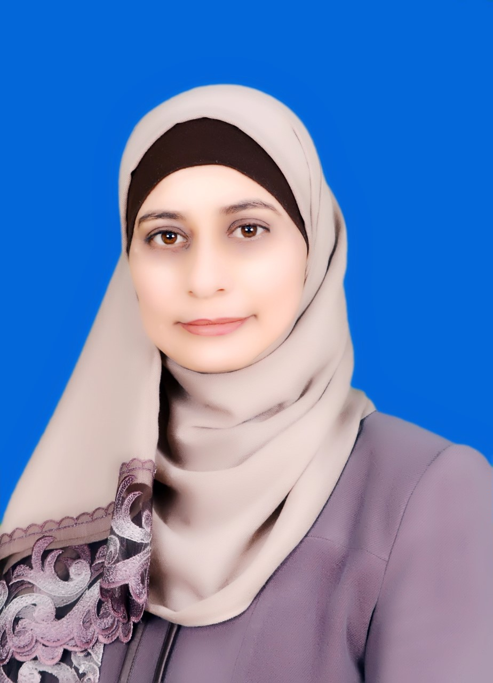

• Name: - Dr. Asma’a Ali Abd Elhadi Abu Qbeita.

• Place of Birth: - Ma’an.

ADDRESS
• Address: - Al Sateh Area.

• City: -Ma’an.

• Country: - Jordan.

• Post Code: - 71111

• E-mail:- asmaasaleh16@hotmail.com
asma'a.abuqbeita@ahu.edu.jo

EDUCATION

• University: - Yarmouk Location:-Irbid

• Degree: -PhD. Duration: -2013-2016.

• Specialization: -Curricula and Methods of Teaching English(TEFL).

• University: - Mu’tah. Location: -Karak.

• Degree: -Master’s. Duration: -2004-2006.

• Specialization: -Curricula and Methods of Teaching English.

• University: - Al -Hussein Bin Talal University Location: - Ma’an.

• Degree: - Bachelor’s Duration: -1997-2001.

• Specialization: -English Teacher.

EXPERIENCE

• Al -Hussein Bin Talal University Location: - Ma’an
Position:-Instructor "A" Year: 2016-Till now

• Al -Hussein Bin Talal University Location: - Ma’an.
Position:-Instructor "B" Year: 2011-2015

• Al -Hussein Bin Talal University Location: - Ma’an.
Position: -Lecturer. Year: 2008-2011

• Al -Hussein Bin Talal University Location: - Ma’an.
Position: -Supervisor of Practical Course. Year: 2007-2008

• Ministry of Education. Location: -Jordan.
Position: - English Teacher. Year: -2001-2007

COMMITTEES

• A member of the Student Disciplinary Committee at Al Hussein Bin Talal University
• A member of the Social Committee - Al Hussein Bin Talal University.
• A member of the Committee for interviewing new teachers at Al-Hussein Bin Talal University School

RESEARCH INTERESTS___________________________________________

• Modern teaching methods and their impact on learning English as a foreign language (listening, speaking, reading, writing).
• Content Analysis.
• Preparing and training pre-service practical education students

TAUGHT COURSES

• Practical Course/English Teacher.

• Practical Course/Kindergarten Teacher.

• Methods of Teaching English (2).

• Methods of Teaching English/ Classroom Teacher.

• Language Skills /Kindergarten.

• Methods of Teaching English for the First Three Grades.

• Remedial English (99)

• English Language (101)

• English Language Skills (102)

• Qualified Program in English for Master Students
PROFESSIONAL QUALIFICATIONS

• International Computer Driving License (ICDL)

• A Critical Thinking Skills Course.

•A New Teachers Training Course.

•A Genetic Assessment Strategies Course.

•Using Computer in Teaching English for The First Three Classes.

Publications

- Abu Qbeita, A. (2016). Effect of Blended Learning on Jordanian EFL Learners' Reading Comprehension and Use of Metacognitive Reading Strategies. Ph.D. Dissertation, Yarmouk University.
- Abu Qbeita, A., & Baniabdelrahman, A. (2016). Metacognitive Reading Strategies Employed by Al-Hussein Bin Talal University Students in Jordan. Dieassat: Educational Sciences.
− Abu Qbeita, A. (2011). Kindergarten Teachers’ Beliefs about Teaching English in Jordan. An - Najah Univ. J. Res. (Humanities). 25(5). 1435-1462.
- Alghazo, K., Bani Abdelrahman, M. & Abu Qbeitah, A. (2009). The effect of teachers' error feedback on AL-Hussein Bin Talal university students' self-correction ability. European Journal of Social Sciences, 12(1), 142-156.

