CURRICULUM VITAE
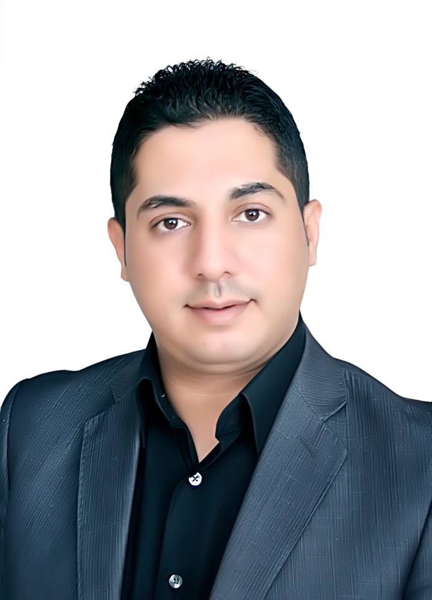
Malek Zakarya Salameh Alksasbeh, PhD

Professor of Computer Information Systems
Faculty of Information Technology
Al-Hussein Bin Talal University(AHU)
Ma'an, Jordan, P. O. Box 20
Mobile: + 962 (79) 5355587
Email: malksasbeh@ahu.edu.jo or malksasbeh@gmail.com

PERSONAL INFORMATION
Date of Birth: June 10, 1983.
Marital Status: Married.
Nationality: Jordanian.

PROFILE
Dr. Alksasbeh is a Full Professor in the College of Information Technology at Al-Hussein Bin Talal University (AHU). His research interests are in the areas of Smart Information Systems, Technology Acceptance, Information Retrieval, Mobility, and Fuzzy sets and Systems. Long term working with Computer and Computer information system area. Highly competitive, self-starter who is organized disciplined. Excellent communication skills both verbal and written demonstrated by ability to work with people of diverse backgrounds. Welcome the challenge of solving problems.

EDUCATION
2012 | PhD, Computer Information Systems, University Utara Malaysia, Malaysia.
2008 | MSc, Information Technology, University Utara Malaysia, Malaysia.
2005 | BSc, Computer Science, Mu'tah University, Jordan.

ACADEMIC EXPERIENCE
January 2022 | Full Professor, Department of Computer Information Systems, Al-Hussein Bin Talal University (AHU), Ma’an, Jordan.
2018 – 2022 | Associate Professor, Department of Computer Information Systems, Al-Hussein Bin Talal University (AHU), Ma’an, Jordan.
2014– 2017 | Assistant Professor, Department of Computer Information Systems, Al-Hussein Bin Talal University (AHU), Ma’an, Jordan.
2013 – 2014 | Lecturer, Department of Computer Information Systems, Al-Hussein Bin Talal University (AHU), Ma’an, Jordan.
2012 – 2013 | Assistant Professor, Department of Computer Science, Al-Baha University, Al-Baha, KSA.
2009 – 2012 | Part Time Lecturer, University Utara Malaysia and College Insaniah University, Malaysia.

ADMINSTRATIVE EXPERIENCE
9/9/2019-2/1/2020 | Acting Dean, College of Information Technology, AHU
2014 – 2015 | Chair, Department of Computer Science, AHU.
Summer 2014 | Acting Chair, Department of Software Engineering, AHU.
2005 – 2007 | Customs Officer, Aqaba Special Economic Zone Authority, Aqaba, Jordan

TEACHING EXPERIENCE
- Internet Programming  - Electronic Commerce  - Database Systems  - Systems Analysis and Design  - Logic Design  - Information Retrieval  - Fundamentals of Information Systems | - Java Programming  - Decision Support Systems  - Object Oriented Programing  - Mobile Technology  - Programming in Business Application  - Special Topics
RESEARCH
Major research interests are:
- Smart Information Systems
- Mobile Technology Acceptance.
- Information Retrieval
- Computer Education
- Fuzzy sets and System

REVIEWER
- Journal of Computer Science.
- Global Journal of Computer Science and Technology.
- Int. J. of Electronic Governance.
- Alexandria Engineering Journal.
- Int. J. of Business Intelligence and Data Mining.
- IEEE Access

PUBLICATIONS
REFEREED JOURNAL ARTICLES
- Esam Alqaraleh, Malek Alksasbeh, Bassam Alqaraleh: Smart Deep Learning Based Human Behaviour Classification for Video Surveillance: Computers, Materials and Continua. 4/2022; 72(3):5593-5605.
- Khaldun Al-Moghrabi1, Ali Al-Ghonmein, Malek Alksasbeh, Ahmad Al-Dalaien: Towards a Cloud Computing Success Model for Hospital Information System in Jordan: International Journal of Advanced Trends in Computer Science and Engineering. 10/2021; 10(2): 1121-1127.
- Malek Alksasbeh, Tamer Abu-Khalil, Bassam Alqaraleh, Mohammad Al-kaseasbeh: Smart job searching system based on information retrieval techniques and similarity of fuzzy parameterized sets. International Journal of Electrical and Computer Engineering 02/2021; 11(1): 635-644.
- Malek Alksasbeh, Ahmad Al-Omari, Bassam Alqaraleh, Tamer Abu-Khalil, Anas Abukarki, Ibrahim Al-kore, Amal Alkaseasbeh: Smart Hand Gestures Recognition Using K-NN based Algorithm for Video Annotation Purposes. Indonesian Journal of Electrical Engineering and Computer Science 01/2021; 21(1):242-252.
- Malek Alksasbeh, Tamer Abu-Khalil, Bassam Alqaraleh, Anas Abukarki, Tawfeq Al-Rawashdeh, Mohamed Al-Jaffreh: Smart Detection of Offensive Words in Social media using Soundex Algorithm and Permuterm Index: International Journal of Electrical and Computer Engineering10/2021; 11(5).
- Bassam Alqaralleh, Malek Alksasbeh, Ahmad H. Al-Omari: A Novel Pending Interest Table Sharing Scheme Using Neuro Fuzzy Logic For Named Data Networking Communication 1/2021; 99(1): 181-195.
- Malek Alksasbeh, Mohammad Al-kaseasbeh: Similarity and Agreement Measures and Their Application in Medical Diagnostic Prediction System: IEEE Access 12/2020 ;8(99) 228685-228692.
- Bassam Alqaraleh, Malek Alksasbeh, Tamer Abu-Khalil, Harbi Al-Mahafzah, Tawfiq Alrawashdeh: Recognition Of Handwritten Arabic (Indian) Numerals Using Skeleton Matching. Indonesian Journal of Electrical Engineering and Computer Science 09/2020; 19(3)1461-1468.
- Bassam Alqaraleh, Ahmad Al-Omari, Malek Alksasbeh: An Integrated Conceptual Model for m-Government Acceptance in Developing Countries: The Case Study of Jordan. International Journal of Interactive Mobile Technologies 06/2020; 14(6)115-136.
- Tamer Abu-Khalil, Malek Alksasbeh, Bassam Alqaraleh, Anas Abukarki: Robot Navigation System Using Laser and a Monocular Camera: Journal of Theoretical and Applied Information Technology; 04/2020; 98(4) 714-724.
- Tamer Abu-Khalil, Harbi Al-Mahafzah, Malek Alksasbeh, Bassam Alqaraleh: Fuel Consumption Using OBD-II and Support Vector Machine Model. Journal of Robotics 01/2020; 2020(ID 9450178).
- Tamer Abu-Khalil, Harbi Al-Mahafzah, Malek Alksasbeh, Bassam Alqaraleh: Power Optimization in Mobile Robots Using a Real-Time Heuristic. Journal of Robotics 02/2020; 2020(ID 5972398).
- Bassam Alqaraleh, Malek Alksasbeh, Tamer Abu-Khalil, Harbi Al-Mahafzah: The impact of information culture on the adoption of mobile cloud learning in higher education environments. International Journal of Engineering & Technology 04/2019; 8(4) 517-522.
- Malek Alksasbeh, Mohammed Abuhelaleh, Mohammed Amin Almaiah, Mohamed AL-jaafreh , Anas Abu karaki :Towards a Model of Quality Features for Mobile Social Networks Apps in Learning Environments: An Extended the Information System Success Model. International Journal of Interactive Mobile Technologies 05/2019;13(5): 75-93.
- Malek Alksasbeh, Mohammad Al-kaseasbeh, Saba Al-kaseasbeh, Khalid Alemerien, Bassam Alqaraleh: Enhanced Decision Support System Applications Based on Complex Intuitionistic Fuzzy Soft Expert Sets Theory. Journal of Computer Science 05/2018; 14(5):601-612.
- Malek Alksasbeh, Ahmad Al-dala’ien, Bassam Alqaraleh: Factors that Influence the Success of Knowledge Management Implementation in Jordanian Higher Education Institutions. Research Journal of Applied Sciences, Engineering and Technology 7/2018; 15(7):249-260.
- Malek Alksasbeh, Bassam Alqaralleh, Tahseen Alramadin, Khalid Alemerien: An Automated Use Case Diagrams Generator From Natural Language Requirements. Journal of Theoretical and Applied Information Technology 03/2017; 95(5):1182-1190.
- Malek Alksasbeh, Bassam Alqaralleh: Integrating Quality Features into Technology Acceptance Model for Examining the Acceptance of Mobile Banking. Journal of Theoretical and Applied Information Technology 08/2017; 95(16):3737-3748.
- Tahseen Al-Ramadin, Malek Alksasbeh, Moha'med Al-Jafreeh: A New Approach for Automated Job Search using Information Retrieval. Global Journal of Computer Science and Technology 06/2015 ; 15(6):1-7.
- Mohamed Al-Jaafreh, Tahseen Al-Ramadin, Malek Alksasbeh, Ahmed Saidan: Optical Wireless Home Automation System. Global Journal of Computer Science and Technology 08/2015 ; 15(8):1-5.
- Malek Alksasbeh: Integrating mobile technology service quality, trust and cultural factors into technology acceptance of mobile learning. International Journal of Science, Innovation & New Technology, 2/2013; 1(6):11-18.

REFEREED CONFERENCES

- Mohammad Al-kaseasbeh, Saba Al-kaseasbeh, Malek Alksasbeh: Inclusion and Convolution Properties for Certain Class Deﬁned by Convoluted Differential Operator. 3rd International Computer Sciences and Informatics Conference, Balqa, Jordan; 4/2019.
- Malek Alksasbeh, Wan Rozaini Bt Sheik Osman, Huda Bt Hj. Ibrahim: An Acceptance of Mobile Learning for Higher Education Students in Jordan. 2nd World Conference on Information Technology (WCIT-2011), Antalya, Turkey; 11/2011.
- Malek Alksasbeh, Huda Bt Hj. Ibrahim, Wan Rozaini Bt Sheik Osman: Differences in Mobile Learning Acceptance for Higher Education Students in Jordan. 2nd World Conference on Information Technology (WCIT-2011), Antalya, Turkey; 11/2011.
- Malek Alksasbeh, Wan Rozaini Bt Sheik Osman, Huda Bt Hj. Ibrahim: Issues and Challenges for Mobile Learning in Jordanian Universities. Proceedings of the 3rd International Conference on Computing and Informatics, Bandung, Indonesia, Bandung, Indonesia; 06/2011.
- Malek Alksasbeh, Syazwan Abdullah, Wan Rozaini, Sheik Osman, Farihana Elyana: Using Ontology to Define the Structure of the Holy Quran. 4th International Conference on Information Technology (ICIT 2009), Amman, Jordan; 01/2009.

MEMBERSHIP OF UNIVERSITY COMMITTEES

- Head of IT Faculty Council,AHU,2019.
- Member of Deans Council, AHU, 2019.
- Member of IT Faculty Council, AHU, 2018-2019
- Member of scientific Committee of IT Faculty ,AHU, 2020-2021.
- Head of scientific Committee of IT Faculty ,AHU, 2017-2018.
- Member of Academic Activity Committee of IT Faculty ,AHU, 2017-2018.
- Member of the committee for students preparation of competency exam for IT Faculty, 2015-2016.
- Member of the curricula committee of IT Faculty, AHU, 2015-2016.
- Member of the curricula committee of IT Faculty, AHU, 2014-2015.
- Member, University Council, AHU,2014-2015.
- Member of IT Faculty Council, AHU, 2014-2015
- Head of Student Activity Committee of IT Faculty ,AHU, 2014-2015.
- Head of Computer Science Department Council, AHU, 2014-2015.
- Member of Computer Information Systems Department Council, 2013- Present.
PROFESSIONAL TRAINING, WORK SHOP AND CONFERENCES

- Broadband Technologies For Rural Connectivity.
Kuala Lumpur, Malaysia
29 - 31 May 2007.

- Universal Service Obligation (USO) and Rural ICT Development.
University Utara Malaysia (UUM), Malaysia
10 - 13 Dec 2007.

- Online Training - Broadband Technologies for Rural ICT Development
University Utara Malaysia (UUM), Malaysia
20 Oct. - 30 Nov 2008.

- Effective Use of Telecommunications/ICTs In Response to Disasters: Saving Lives.
University Utara Malaysia (UUM), Malaysia
24 - 28 Nov 2008.

- Universal Access & Service and Rural Broadband.
University Utara Malaysia (UUM), Malaysia
2 - 5 Dec 2008.

- 4th International Conference on Information Technology (ICIT)
Amman, Jordan
3-5 June 2009.

- Universal Service Policies and Practices.
University Utara Malaysia (UUM), Malaysia
- Aug. - 03 Oct 2009.

- SEM Using AMOS Workshop
Penang, Malaysia
25- 27 June 2010.

- Workshop on “e-Applications and Services”
Bangkok, Thailand
- - 25 Sept 2010.

- SEM For Small Sample and Non-Normal Data Workshop
University Utara Malaysia (UUM), Malaysia
18- 19 April 2011.

- International Conference on Rural Development and Entrepreneurship 2011 (ICORE )
Sarawak, Malaysia
- - 30 May 2011.

- Instrument Development Workshop
University Utara Malaysia (UUM), Malaysia
1 June 2011.

- 3rd International Conference on Computing and Informatics
Bandung, Indonesia
8-9 June 2011.

- Structuring Public Private People Partnership (PPPP) to Fund Rural Broadband Infrastructure.
Kuala Lumpur, Malaysia
  - Nov 2011.

- 2nd World Conference on Information Technology (WCIT-2011)
Antalya, Turkey
  - Nov 2011
- Open Source Software (OSS) 3d Animation Skill Improvement for Asian Universities.
University Utara Malaysia(UUM), Malaysia
30 January – 10 February 2012

17- Workshop on Computer and Information Sciences
Albaha, KSA
20 - 21 March 2013.
18- Support to Research, Technological Development and Innovation in Jordan
Amman, Jordan
23 April 2014.

19- Toward A University Enterprise Alliance in Jordan
Amman, Jordan
31 March 2015.

20- AICCSA 2018 : 15th ACS/IEEE International Conference on Computer Systems and Applications
Aqaba-Jordan
28 October 2018

21- 3rd International Computer Sciences and Informatics Conference
Balqa, Jordan
1 April 2019

22- 1st Annual Undergraduate Information Technology Conference
Karak- Jordan
2 April 2019

23- Advantages and Disadvantages for E-learning in Jordan
Ma'an-Jordan
25 December 2020

VOLUNTEER WORK

Attend in more than 60 conferences, meeting, and workshops about youth (internal and around the globe).

SOCIAL CONTRIBUTIONS

- Chairman of the Administrative Committee - Karak Youth Center 1999-2000
- Member of the INJAZ Committee and King Abdullah II / Mu'tah University Fund 2002-2005
- Chairman of the Administrative Committee – INJAZ / Mu'tah University 2002
- Chairman of the Language Club / Mu'tah University 2003
- Head of the Leadership Team / Mu'tah University 2004
- Head of the ALRWAD Team / Mu'tah University 2005
- President of the Parliament of Mu'tah University 2004
- International Student Representative / University Utara Malaysia 2011-2012

