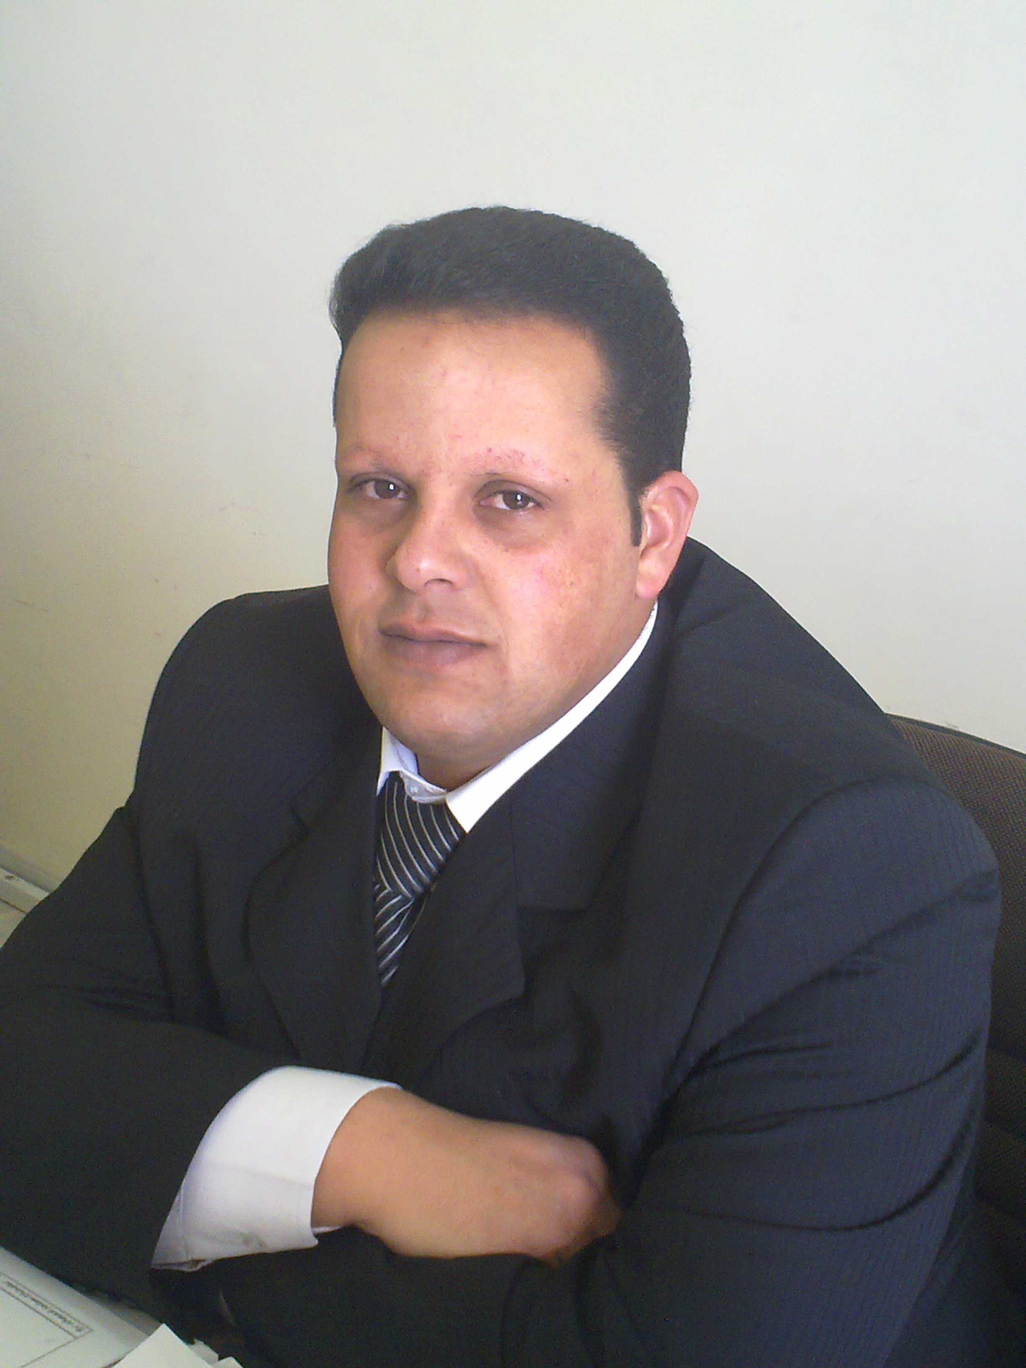
Ahmad khalil ma`aqbeh
Dept. of Biology
Al - Hussein Bin Talal University
Jordan-Ma’an PO Box 20
Tel: + 962 - 3 - 2179000
Fax: + 926 - 3 - 2179050
E-mail: hamaideh@ahu.edu.jo
hamaidehahmad@yahoo.com

Personal information
Date of Birth : 27/02/1982
Place of Birth : Faqu`
Sex : male
Martial Status : Single
Nationality : Jordanian

Education
Bachelor Degree (BSc) Biology from Mu'tah University – Jordan 2000-2004.
Master Degree (MSc) Biology from Mu'tah University – Jordan 2005-2007.

Employment History
- Working a lecturer in biology Department , AL-Hussein bin talal university ,from 2009 until now.
-Working a teacher of biology , ministry of education , Jordan , from 2004 to 2009 .

Training Courses
- Training program ( ICDL ) , 120 training hours .
- Training program ( world links ) , 160 training hours.
- Training program in SPSS , 60 training hours .

Teaching Experience
1- General Biology 1
2- General Biology lab. 1
3- Animal physiology
4- Genetics
5- Cell Biology
6- Biostatistics

Skills
- I 'm collaborative with others, I work as member within a team , I work harder , I'm
ambition , and Easily can cope with changeable work nature.

Languages
- Arabic Language , excellent reading , writing and speaking .
- English Language , very good reading , writing and speaking .

Publications
Ma`aqbeh, A, 2010. Effect of Temperature on Phagocytosic Activity in Garden Snails Helix aspersa. Advances in Environmental Biology, 4(2): 271-276.

