Curriculum Vitae
Alá Salem Ali Alnaimat
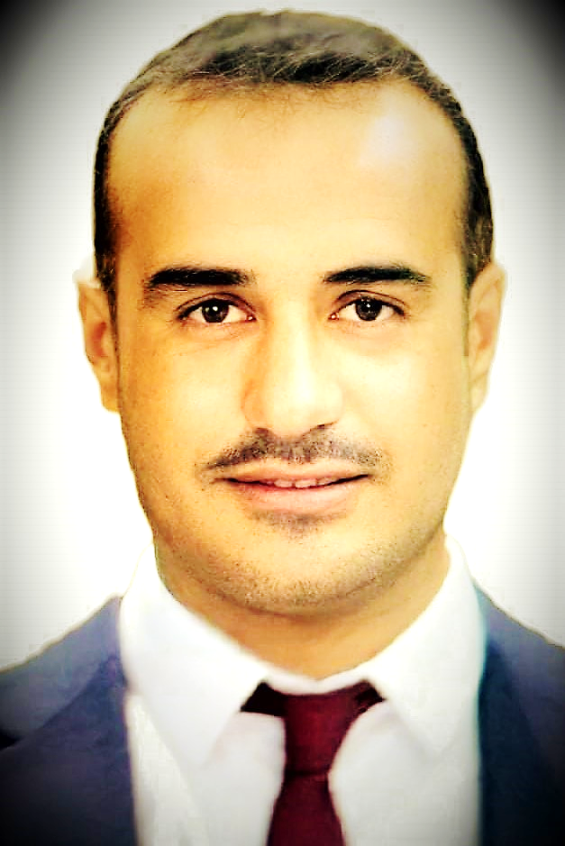
June 2021

Personal _________________________________________________
Place of Birth | Jordan
Date of Birth | March 28, 1986
Marital Status | Single
Nationality | Jordanian
Work Address | Department of Chemistry, College of Science, Al-Hussein Bin Talal University, Ma′an, Jordan. Phone: +962-3-2179000 Ext.:xxxx, E-mail: ala.alnaimat@ahu.edu.jo
Academic Rank (date) | Assistant Professor (2021)
Permanent Address | Al-Farthakh - Maan, Jordan.  E-mail: ala.alnaimat@ahu.edu.jo

Academic Qualifications __________________________________________
2015 - 2020 | Ph.D., Analytical Chemistry, University of Santiago de Compostela, Spain
2014 – 2016  2008 – 2014 | M.Sc., Analytical Chemistry, University of Santiago de Compostela, Spain  M.Sc., Chemistry, Mutah University, Al-Karak, Jordan
2001 - 2005 | B.Sc., Chemistry, Al-Hussein Bin Talal University, Ma′an, Jordan

Specialty _________________________________________________________
General Specialization: | Chemistry
Specialization : | Analytical Chemistry

Career History ___________________________________________________
January 2021 -Present | Assistant Professor, Department of Chemistry, College of Science, Al-Hussein Bin Talal University, Ma'an, Jordan.
January 2008 - April 2014 | Graduate Teaching Assistant/Assistant Instructor, Faculty of science, Chemistry departments, The University of Jordan, Amman, Jordan

Administrative Experience _________________________________________
Committees
2018 - 2021 | Student Representative in the council of analytical chemistry department, University of Santiago de Compostela, Spain
HONORS, SCHOLARSHIPS, AWARDS AND GRANTS_________________
2005 | Ministry of Education Grant  Grant from the Ministry of High Education (Jordan) for studying B.Sc in Chemistry at Al-Hussein Bin Talal University (Jordan) 2005 - 2008
2014 | Erasmus Mundus Grant  Grant from Erasmus Mundus project for studying Master in Chemical  Investigation Research and Industrial Chemistry, University of Santiago de  Compostela (Spain) 2014 - 2016
2017  2018 | Al-Hussein Bin Tala University Grant  Grant from Al-Hussein Bin Talal University for studying PhD in Analytical Chemistry at the University of Santiago de Compostela (Spain) 2017- 2020  BNASS 2018 student Bursary  BNASS 2018 student Bursary, The Royal Society of Chemistry, St Mary’s  University, Strawberry Hill, Twickenham, (UK).

Research Interest ___________________________________________________
- Development of new methods for the determination of toxic materials in food and beverages using spectrometric techniques.
- Analysis of elements in Food, drinks, and Environmental matrices.
- Assessment of Microplastics and Environmental pollutants.

Publications ________________________________________________________
Peer-reviewed journal articles
- Alá S. Alnaimat; Barciela-Alonso, María Carmen; and Pilar Bermejo-Barrera. (2019) Determination of bisphenol A in tea samples by solid phase extraction and liquid chromatography coupled to mass spectrometry. Microchemical J. 147, 598-604. https://doi.org/10.1016/j.microc.2019.03.0262.
- Alá S. Alnaimat; Barciela-Alonso, María Carmen; and Pilar Bermejo-Barrera. (2020) Development of a sensitive method for the analysis of four phthalates in tea samples: Tea bag contribution to the total amount in tea infusion. Food Additives and Contaminants: Part A, 37:10, 1719-1729, https://doi.org/10.1080/19440049.2020.17861703.
- Alá S. Alnaimat; Barciela-Alonso, María Carmen; Paloma Herbello-Hermelo, Raquel Domínguez-González; and Pilar Bermejo-Barrera. (2021) In vitro assessment of major and trace element bioaccessibility in tea samples. Talanta 225, 122083 doi.org/10.1016/j.talanta.2021.122083

Books and book chapters
- Study of Trace Elements and Organic Compounds of the Toxicological Interest in Tea Samples. PhD Thesis, Universidade de Santiago de Compostela 2020
Patents
- N.A.

Conferences And Proceedings _____________________________________
- VII Encontro da Mocidade Investigadora, Santiago de Compostela, (Spain) 27th - 29th May, 2019.
- International conference of Mission 10 000 Conferencia Internacional Nanogateway"Nanotecnología: Un facilitador para la Bioeconomía”, Braga, (Portugal), 17th October 2018.
- 19th Biennial National Atomic Spectroscopy Symposium (BNASS 2018), St Mary’s
University, Strawberry Hill, Twickenham, (UK) 2nd– 4th July 2018.
- 19th International Symposium of Advanced in Extraction Technologies (ExTech 2017), University of Santiago de Compostela, (Spain) 27th - 30th of June 2017.
- Simposio: Nuevos retos en el desarrollo y aplicación de tecnologías ambientales,
- Santiago de Compostela, (Spain) 27th April 2017
- 6. XX Reunión de la Sociedad Española de Química Analítica (SEQA 2015). Santiago de Compostela, (Spain) 1st - 3^{ed} July 2015.

Teaching__________________________________________________________
Courses Taught-undergraduate
- General Chemistry (Chem 101), Al-Hussein Bin Tala University, Maan, Jordan
- General Chemistry Lab (Chem 103), Al-Hussein Bin Tala University, Maan, Jordan
- Analytical Chemistry Lab (Chem 212), Al-Hussein Bin Tala University, Maan, Jordan

Courses Taught-postgraduate
- N.A

Skills__________________________________________________________
Languages
- Arabic (Native)
- English (Excellent)
- Spanish (Excellent)
- Galician (Basic)

Computer Programs
- Statgraphics – Statistical analysis Software, University of Santiago de Compostela

