PERSONAL INFORMATION | Mohammad Al Sharari
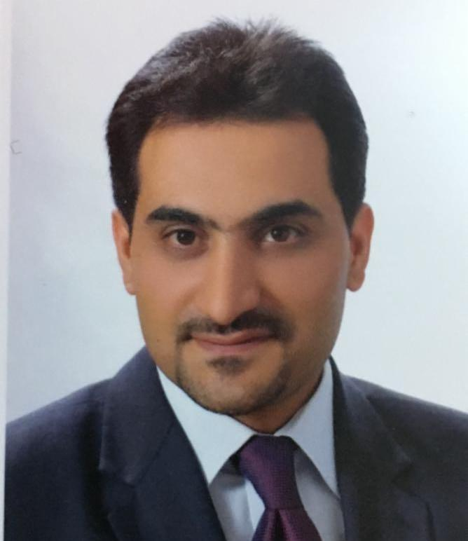 |   Ma'an (Jordan)

+962776606202

sharari.m.i@ahu.edu.jo

WORK EXPERIENCE

17/9/2018 - Present  08/03/2012–17/9/2018 | Full Time Lecturer (Assistant Professor)  Al Hussein bin Talal University - Ma’an, (Jordan)  Teaching these Topics:  - Power Systems Analysis  - Electric Circuits and Machines  - Transmission and Distribution  - Special Topics (Solar Energy)  Supervision Engineer
17/9/2018 - Present  08/03/2012–17/9/2018 | Public Works and Housing - Ma'an Directorate, Ma'an (Jordan)

04/01/2004–01/08/2006 | Electrical Technician Locomotives
04/01/2004–01/08/2006 | Aqaba Railway Corporation, Ma'an (Jordan)

EDUCATION AND TRAINING

12/2013–06/2017 | Phd in Engineering sciences (Energy complexes and systems).
12/2013–06/2017 | National Technical University of Ukraine / Igor Sikorsky Kyiv Polytechnic Institute, Kyiv (Ukraine)

09/2009–06/2010 | Master of Electrical power plants
09/2009–06/2010 | Sevastopol National university of nuclear energy and Industry, Sevastopol (Ukraine)

09/2007–07/2009 | Bachelor of Electrical Engineering
09/2007–07/2009 | Sevastopol National University of nuclear Energy and Industry, Sevastopol (Ukraine)

09/2001–04/2003 | Technical Diploma in Electrical Technology \Electrical power
09/2001–04/2003 | Mosul Technical Institute, Mosul (Iraq)

01/10/2012–11/11/2012 | Buildings Electrical Design
01/10/2012–11/11/2012 | Engineering Training Center, Ma'an (Jordan)

01/2010 | 2D AutoCAD
01/2010 | Engineering Training Center, Ma'an (Jordan)

10/2009 | Primavera III (First Level)
10/2009 | Engineering Training Center, Ma'an (Jordan)

06/2009 | TOEFL Preparation
06/2009 | Engineers Training Center, Ma'an (Jordan)

PERSONAL SKILLS

Mother tongue(s) | Arabic
Other language(s) | UNDERSTANDING |  | SPEAKING |  | WRITING
Other language(s) | Listening | Reading | Spoken interaction | Spoken production
Russian | C2 | C2 | C2 | C2 | C2
Ukrainian | C1 | C1 | C1 | C1 | C1
English | B1 | B1 | B1 | B1 | B1
Levels: A1 and A2: Basic user - B1 and B2: Independent user - C1 and C2: Proficient user
Common European Framework of Reference for Languages

Research Areas

- Power Systems Integration
- Solar Energy
- Energy Management

