Curriculum Vitae
Eid Ahmad Eid Abd AL Razaq
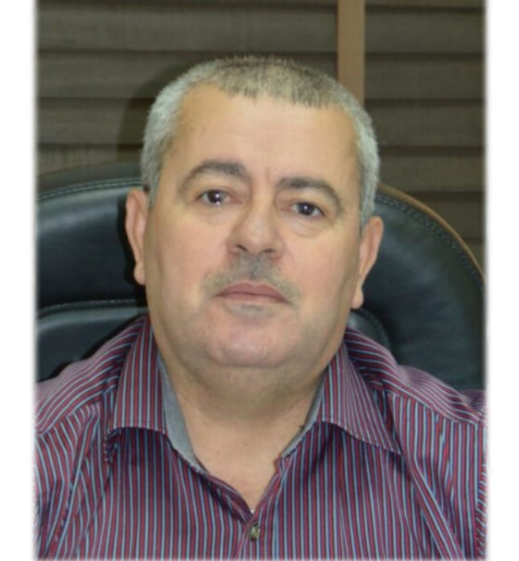

Personal _________________________________________________
Place of Birth | Jordan
Date of Birth | March 8, 1973
Marital Status | Married
Nationality | Jordanian
Work Address | Department of Chemistry, College of Science, Al-Hussein Bin Talal University, Ma′an, Jordan. Phone: +962-3-2179000 Ext.:xxxx, E-mail: ealzouby@ahu.edu.jo
Academic Rank (date) | Associate Professor (2011)
Permanent Address | Ramtha, Jordan. Cell Phone:+962796862267, E-mail: eidalzooby@yahoo.com

Academic Qualifications __________________________________________
2000- 2003 | Ph.D., Inorganic Chemistry, Mosul university, Mosul, Iraq
1998 - 2000 | M.Sc., Inorganic Chemistry, Mosul university, Mosul, Iraq
1991 - 1995 | B.Sc., Applied Chemistry, Jordan University of Science and Technology, Irbid, Jordan

Specialty _________________________________________________________
General Specialization: | Chemistry
Specialization : | Inorganic Chemistry and Theoretical chemistry

Career History ___________________________________________________
October 2011 –Present  September 2004 – October 2011 | Associate Professor, Department of Chemistry, College of Science, Al-Hussein Bin Talal University, Ma'an, Jordan.  Associate Professor, Department of Chemistry, College of Science, Al-Hussein Bin Talal University, Ma'an, Jordan.
September 2012 – August 2018 | Visiting Associate Professor, Department of Chemistry, Faculty of Science, Islamic University in Madinah, Madinah Al Monawrah - Saudi Arabia
September 2008 - September 2010 | Head of chemistry department in Al-Hussein Bin Talal University

Administrative Experience _________________________________________
Positions
September 2010- September 2011 | Member of Al- Hussein Bin Talal University council
September 2011 - January 2012 | Deputy Dean of the College of Science, Al-Hussein Bin Talal University, Ma'an, Jordan
January 2012 - September 2012  December 2018 – December 2020 | Acting dean of the college of science, Al-Hussein Bin Talal University, Ma'an, Jordan  Deputy Dean of the College of Science, Al-Hussein Bin Talal University, Ma'an, Jordan

Research Interest ___________________________________________________
- Synthesis and characterization of new complexes and ligands containing different donor atoms.
- Theoretical calculations of new compounds.
- Study the biological activity of the compounds.

Publications ________________________________________________________
Peer-reviewed journal articles

Nabeel H. Buttrus and Eid A. Abd Al-Razaq, Reaction of VOCl₃ and TaCl₅ with the Ligands 1,2-Bis(o-Aminophenylthio)ethane and 1,1,2,2-Tetrakis (o-aminophenyl) Ethene, Jordan journal of applied science, Volume 6, No. 1, 2004.

- Eid A. Abd Al-Razaq, Manal A.Al-Shama’a, Omar M. Al-Ramadani, Talal A.Al-Allaf, Synthesis and Characterization of Organosilicon(IV) Complexes with Some Schiff-base derivatives , Int.J.Chem.Sci:3(2), 253-262, 2005.

- Nabeel.H.Buttrus¹,Eid.A.Abd Alrazaq and Abdo K.AL-Sger, Synthesis and Characterization of some new semi conducting dinuclear Platinum (II) complexes containing 1,1,2,2-tetrakis-(substituted phenylthio) ethylene , Int.J.Chem.Sci.5 (3), 1111-1120, 2007.

- Ammar A. Ibrahim and Eid A. Abdalrazaq, Physical Properties of Phenol Compound: Semi-empirical Calculation of Substituent Effects [Part One], American journal of applied sciences, 6 (7), 1385-1389, 2009.

- Eid A. Abdalrazaq, Nabeel H. Buttrus, Abd Al-moujod M. Abd Al-Rahman, Synthesis and characterization of gold (III) complexes with bis-(1,4-sodium thioglucolate) butane ligand, Asian Journal of Chemistry, Vol. 22, No. 3 , 2179-2186, 2010.

- Eid A. Abdalrazaq , Omar M. Al-Ramadane, Khansa S. Al-Numa
Synthesis and Characterization of Dinuclear Metal Complexes Stabilized by Tetradentate Schiff Base Ligands, American journal of applied sciences; 7 (5), 628- 633, 2010.

- Eid Abdalrazaq, Nabeel Buttrus, Wedad Al-Kattan, Abdel Aziz Jbarah and Mansour Almatarneh, Reactions of Pd²⁺ and Pt²⁺ with Pyrrolidinedithio Carbamate and Cystine Ligands:Synthesis and DFT Calculations, Journal of Sulfur Chemistry, Vol 32, No. 2, 159-169, April 2011.

- Ammar A. Ibrahim, Eid A. Abdalrazaq, Maher A. Ibrahim, Rosiyah Yahya and Entesar A. Sulliman, Quantum Chemical Calculations (QSAR) of Antipyrine Drug and Its Metabolites, Asian Journal of Chemistry, Vol 23, No. 9, 2011.

- Eid A Abdalrazaq, Omar M. Alramadane and Khansa S. Alnuma, Synthesis and characterization of some mixed ligands complexes from o-phthalic acid as primary ligand, International Journal of Applied Chemistry, Vol 7, No. 1, 93-100, 2011.

- Nabeel H. Buttrus, Sabah.M. Mohamed, Assim.A. Sabah, Eid.A. Abdalrazaq, Synthesis and Characterization of Ni²⁺, Cu²⁺ and Zn²⁺ Complexes with Benziimidazole-2-thionate, Diphosphene and their Reaction with Iodine, Asian Journal of Chemistry, Vol.25, No.9,4856-4860, 2013.

- S. Al-Thyabat and Eid A. Abdalrazaq, H. Alnawafleh, K.Al-Tarawneh, Beneficiation of oil shale by froth flotation: Critical review,, The open mineral processing journal, 7, 1-12, 2014.

- Eid Abd Al-Razaq , Nabeel Buttrus, Enas H.Mohammed and Abdel Aziz Jbarah, Synthesis and DFT Calculations of Dinuclear complex of Co²⁺, Ni²⁺ and Cu²⁺ with macrocyclic Schiff base Ligands, Oriental journal of chemistry, Vol.32, No. 1, 137-148,2016.

- Ammar A. Ibrahim, Ali Y. Abd-Alrazzak, Eid A. Abdalrazaq, Tamara Shamil, Entesar A. Sulliman, Theoretical Prediction of Lipophilicity for Some Drugs Compounds, Oiental journal of chemistry, vol.36 No.(1), 2020, 114-119.

- Ali Mahmood Ali, Taghreed H Al-Noor, Eid A. Abdalrazaq, and Abdel Aziz Qasem Jbarah, Synthesis and DFT Study of the Complexation of Schiff Base Derived Curcumin and L-Tyrosine with Al(III), Ag(I), and Pb(II) Metal Ions, Indones. J. Chem., 2021, 21 (3), 708 - 724.

- Eid A. Abdalrazaq, Taghreed Hashim Al-Noor, Ghassan Thabit Shinain, Mohamed Mahdi Jawad and Abdel Aziz Qasem Jbarah, Synthesis, DFT Calculations, DNA interaction and Antimicrobial Studies of Some Mixed Ligand Complexes of Oxalic acid and Schiff Base Trimethoprim with Various Metal Ions. In submission process.

Conferences And Proceedings _____________________________________
- The 9th International Conference on Chemistry and its Role in Development, Mansoura – sharm El-Sheikh, April 16-19/2007, Egypt.

- The 15th Arab Chemical Conference (ACC 15), 20-22 April 2010.
Faculty of Science- Albaath University- Homs- Syria

- International Conference on Chemistry and Chemical Process ICCCP 2011, 28-29 May 2011, Bangkok, Thailand.

- Conference in minerals engineering 2012, 7-8 February 2012, Lulea University of Technology, Luleå city, Sweden.

- First Chemistry Symposium – 2013 “Recent Advances in Chemistry”, 24 April 2013, Faculty of Science – Taibah University. Saudi Arabia Kingdom.

- International Chemistry Conference (ICC), March 27-29, 2019 at Bahauddin Zakariya University, Multan, Pakistan.

Teaching__________________________________________________________
Courses Taught-undergraduate
1- General chemistry 1
2- General chemistry 2
3- General chemistry lab1
4- General chemistry lab.2
5- Inorganic chemistry 1
6- Inorganic chemistry 2
7- Inorganic chemistry 3
8- Inorganic chemistry lab.
9-Industrial inorganic chemistry
10- Special topics in inorganic chemistry
11- Descriptive chemistry of elements

Courses Taught-postgraduate
- Coordination chemistry
- Organometallic chemistry
- UV-electronic transitions and Magnetism
- Group Theory

Skills__________________________________________________________
Languages
- Arabic (native)
- English (excellent)

Computer Programs
- Gaussian program
- ChemOffice
- HyperChem
- Molecular Mechanics MM2 and MM+

