Curriculum Vitae
Name: | SALEH ESMAIL RAWADIEH
Date of Birth: | MAY-27-1976
Nationality: | JORDANIAN
Permanent Address | JORDAN-PETRA
Mobile: | 0797447344, 0776746707
Email | srawadie@gmail.com  rawadieh@ahu.edu.jo

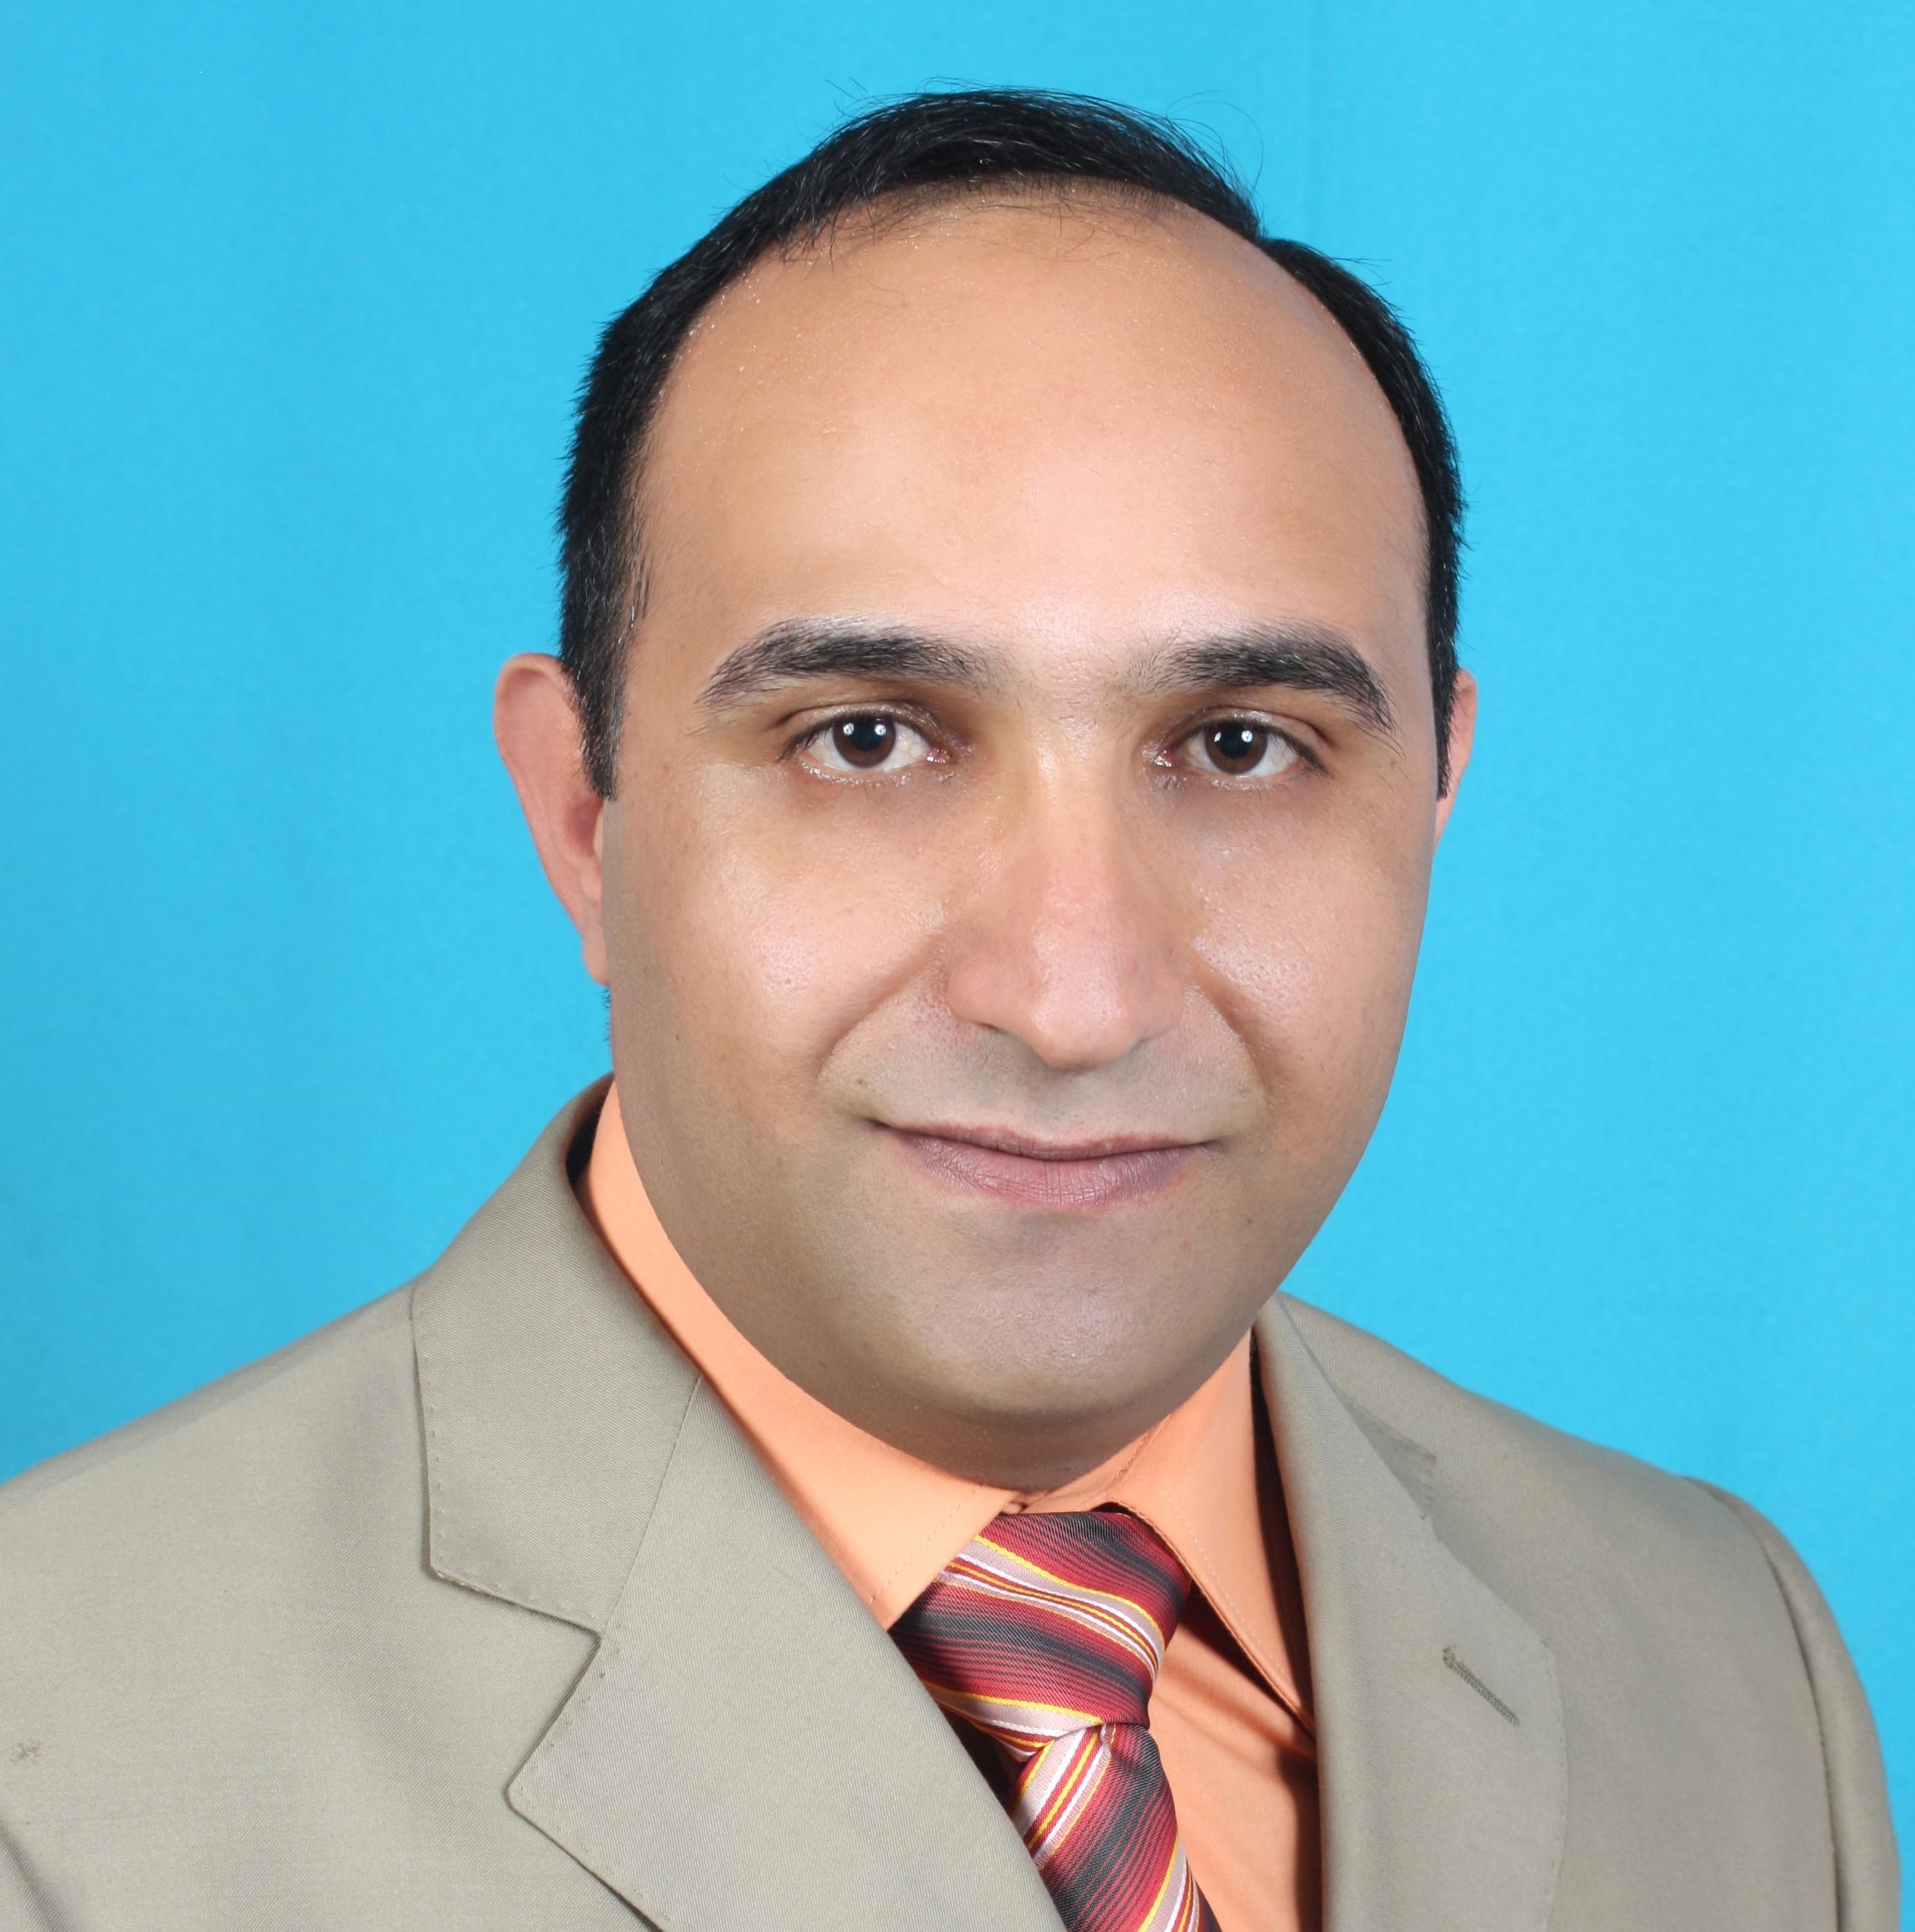

Education

- PhD in Chemical Engineering, University of Sydney, Sydney, Australia, 2005 – 2009.
- Master of Engineering Studies, University of Sydney, Sydney, Australia, 2004 – 2005.
- Advanced Courses in Environmental Engineering, California State University, Sacramento, 2001.
- Bachelor Degree in Chemical Engineering-University of Jordan, Amman, Jordan, 1994-1999.
- Scientific Stream Tawjehee Certificate, Wadi Mousa Secondary School, 1993-1994.

Experiences

August 2014 – up to date.
Associate Professor at Al-Hussein Bin Talal University, Department of Chemical Engineering.
August 2009 – August 2014.
Assistant Professor at Al-Hussein Bin Talal University, Department of Chemical Engineering.
During those periods, I’ve been working as:
- Director of Renewable Energy Center, September 2016 - up to date.
- Study bids of designing and building a 3 MW PV plant under D.B.O.T (design, build, operate and transfer) at Al-Hussein Bin Talal University.
- Study bids of designing and building a 50 MW PV plant at Al-Hussein Bin Talal University.
- Supervise all stages of building a 3 MW PV plant at Al-Hussein Bin Talal University, including testing, termination and commissioning.
- Prepare contracts and tenders.
- Study the impact of PV plants on the grid

- Head of Chemical Engineering Department, September 2013 - September 2016.

- A lecturer for several courses: Separation Processes, solid particulate, chemical industries, chemical reaction engineering I & II, principles of chemical Engineering, physical chemistry, thermodynamic 1, fluid mechanics, process dynamics and control, engineering mathematics, Process Modeling by Statistical Methods, safety engineering, process Modeling and Simulation, and supervising many Graduation projects

- Director of Engineering Workshops, April 2010 – November 2011.

- Be Responsible for the day to day safe and efficient running of the workshops.
- Coordinate resources, (operational & human) schedules and activities to effectively manage jobs.
- Ensure supplies are ordered for each job.
- Assist with quoting, project management, materials purchasing and quality checks.
- Provide oversight and check job estimates.
- Manage inward goods, checking quantities, dispatching goods and receipting invoices.
- Regularly report progress on each job and quickly manage delays.
- Act as a technical advisor on key projects and other areas of the business as requested.
- Respond to client’s requests and keep the communication channels open to ensure information is accurate.
- Receive and review feedback from customers and follow up to ensure customer satisfaction.
- Investigate customer complaints and concerns arising from products and suggest appropriate solutions.
- Develop and implement systems to record, file and store information pertaining to client inquiries.
- Identify staff that require on-going training and implement training opportunities to ensure their skills are improved.
- Work with trainee and semi-skilled staff to improve their technical skills.
- Provide feedback to staffs that are not performing to the expected level and ensure human resources are informed of trends in performance.
- Promote a Health and Safety culture within the business.

July 2004 – July 2009.
Postgraduate studies (Master and PhD) in the University of Sydney: The PhD Thesis title is: Variable Configurations of Integrated Reaction and Separation for Enhanced Performance.

During This period, I've been employed as:

- Tutor in The School of Chemical Engineering, 2007 – 2009:

- Tutored various subjects in the school's undergraduate program, including Applied Mathematics for Chemical Engineering and Process Design
- Tutor who had responsibility to develop most of subject, Applied Computing for Master of Professional Engineering. This included developing the course outlines, slides and additional course materials.
- Research Assistant in The School of Chemical and Bimolecular Engineering, March – July, 2009

March 2000 – July 2004.
Water Authority of Jordan, Wastewater Treatment Plant. During This Period I was working as:

- Lead Process Engineer

- Controlling issuing decisions that regard process parameters
- Supervising a team of process operators and lab technicians
- Supervising, over viewing, And Analyzing obtained lab results
- Carrying out all necessary procedures (Quality Control \Quality Assurance) in Order to Assure high quality effluent of the system
- Coordinating pumpage and maintenance time of pump stations and treatment plant
- Implementing SCADA System for the operation of treatment plant and the associated pump stations

- Manager for treatment plant and pump stations, October, 2001 to July, 2004

- Managing and supervising up to 50 employees including engineering, maintenance, operation and workers staff
- Issuing necessary purchase orders
- Member of tendering and pricing department
- Supervising the associated safety procedures and plans of wastewater plants
- Coordination with private and international organizations
- General public relations and human resources management

Program training services for Operation and Maintenance of wastewater treatment plants, for Petra wastewater plant staff, November 2000 – 2003, Morganti Group incorporated.

Additional and continuing education

- Two months training course at Aqaba industrial complex (phosphate company) Graduation requirements.
- Training services in operation and maintenance of wastewater treatment plant – one-year training program, Morganti Group Inc.
- Wastewater treatment and reuse, March 11-29, 2001- USAID in cooperation with University of Jordan – Amman, Jordan.
- Operation of wastewater treatment plants, volume (I), 2001, Amman – Jordan, Morganti Group Inc, in cooperation with California State University, Sacramento.
- Operation of wastewater treatment plants, volume (II), 2001, Amman – Jordan, Morganti Group Inc, in cooperation with California State University, Sacramento.
- Advance waste treatment, 2001, Amman – Jordan, Morganti Group Inc, in cooperation with California State University, Sacramento.
- Management of wastewater treatment plants, March, 10-21, 2002 – USAID in cooperation with University of Jordan – Amman, Jordan.

Area of Research and Publications

Integrated Reaction and Separation Systems
Many industrially important chemical reactions are limited by the equilibrium conversion of reactants within a feed and product mix. For most chemical processes, the effluent from the reactor is separated into unconverted reactants, by-products and products. The unconverted feed is usually recycled, and the products and by-products are separated for meeting requisite specifications. Process Intensification (PI) through integrated reaction and separation, presents one of the most important trends in today’s process technology. It consists in the development of innovative processes that offer drastic improvements in chemical manufacturing and processing, substantially decreasing equipment volume, energy consumption, or waste formation, and ultimately leading to cheaper, safer, sustainable technologies. This combining of the reaction and separation steps in a single unit operation known as reactive separation process (RSP) or integrated reactive separation (IRS) and the process unit is called a multifunctional reactor. The potential advantages of process integration are:
- Greater productivity
- Higher selectivity
- Reduced energy consumption
- Improved safety
- Reduced catalyst requirement
- Achieve difficult separations
- Heat transfer integration
- Avoidance of chemical wastes
Integrated Design, Optimization and Control
The emphasis in industry on energy savings, sustainable processes and environmental protection has driven process systems engineers, including design and operations engineers, to incorporate a number of crucial steps in developing integrated designs of chemical processes. Design teams are required to integrate the process with control to satisfy economical, environmental and social objectives, while at the same time achieving optimal performance.
Past Research
The purpose of my thesis was to investigate the enhancement of reactive systems using multifunctional reactors. The catalytic separative configurations with optimization of operating conditions were explored in such systems. Fixed-bed columns containing solid catalysts and adsorbents were employed for simultaneous reaction and separation. Theoretical and experimental evaluations of packed-bed adsorptive reactors with and without pressure swing (PSR) effect were been carried out in order to gain conceptual understanding of how the layering of the catalyst and adsorbent within a bed would affect the separation enhanced reaction. Three different reaction schemes were considered: metathesis of propene, dehydrogenation of 1-butene, and steam reforming of methane (SMR). The former reactions represent a single limited-equilibrium reaction case in which the kinetics and thermodynamics of the reaction enables operation at mild condition such as ambient. The product of interest (ethene) could be recovered in the high-pressure reaction/adsorption stream by removing 2-butene and propene.
Current Research
Reaction kinetics and the mechanisms and thermochemistry

Due to the deficiency of research funding and inadequate research resources in Jordan, I couldn't add much to my basic research of interest. So, I have joined my department colleague's interests in the fields of reaction kinetics and the mechanisms and thermochemistry of species. We had made a contributions to the understanding of the formation and destruction of highly toxic pollutants from thermal processes, low-temperature oxidation of hydrocarbons and behavior of nitrogen content in fuels.

Solar Desalination
Energy and water are both essential for sustainable development in all sectors. Jordan and most of the Middle East countries are facing serious challenges in terms of limited resources of energy and fresh water. Jordan imports of about 98% of its energy need which accounts for 13% of the GDP in 2009. Ma’an city has favourable geographic and climatic conditions that allow the development of the major national productive projects utilizing renewable energy sources. This is indicated by a number of imported renewable energy technologies (solar and wind) being constructed in Ma’an and other cities in Jordan. My recent research works were focusing on theoretical and experimental investigation of availability of solar radiation in Ma'an region, Jordan (Latitude: 31 N, Longitude: 36 E). A mathematical model was developed and designed to investigate variations of the received solar radiation on horizontal and inclined surfaces of solar stills with different orientations. In addition, a solar desalination model was developed and integrated with the solar radiation model. The output of the validated solar radiation model was used as an input to the solar desalination model. The integrated model was used to investigate the effect of geometrical and operational parameters on the performance of single slope, double slope and pyramidal solar stills. Model simulations were validated against experimental measurements and, then, the optimum settings for the enhanced performance were obtained.

Journal articles:
- Saleh Rawadieh and Gomes, V. G. “Catalyst-Adsorbent Configurations in Enhancing Adsorptive Reactor Performance”: International Journal of Chemical Reactor Engineering, 2007, Vol. 5: p A108.

- Saleh Rawadieh and Gomes, V. G. “Integrated reaction and separation for butadiene production”. The journal of Adsorption.

- Saleh Rawadieh and Gomes, V. G. “Steam reforming for hydrogen generation with in situ adsorptive separation”. International Journal of Hydrogen Energy, 2009, Vol 34, 343-355.

- Marwan Batiha, Mohammednoor Altarawneh, Abdullah Alsofi, Mohammad Al-Harahsheh, Ibrahem Altarawneh, Saleh Alrawadieh. “Theoretical study on the reaction of hydrogen atoms with aniline”. Theoretical Chemistry Accounts, 2011, Vol 129, Issue 6, pp 823-832

- Marwan Batiha, Mohammednoor Altarawneh, Mohammad Al-Harahsheh, Ibrahem Altarawneh, Saleh Rawadieh. “Theoretical derivation for reaction rate constants of H abstraction from thiophenol by the H/O radical pool”. Computational and Theoretical Chemistry, 2011, Vol 970, Issues 1–3, 1–5

- Ibrahem Altarawneh, Khaled Altarawneh, Ala’a H. Al-Muhtaseb, Saleh Alrawadieh, Mohammednoor Altarawneh (2012), “Theoretical study of thermochemical and structural parameters of chlorinated isomers of aniline”. Computational and Theoretical Chemistry, Vol 985, 30-35.

- Ibrahem Altarawneh, Mohammednoor Altarawneh, Saleh Rawadieh. “Theoretical study on thermochemical parameters and IR spectra of chlorinated isomers of nitrobenzene”. Canadian Journal of Chemistry, 2013, Vol 91, No10, 999-1008,

- Saleh Rawadieh, Ibrahem Altarawneh, Heba B. Alateyat, Mohammednoor Altarawneh. “Theoretical study on the unimolecular decomposition of proline”. Computational and Theoretical Chemistry, 2013, Volume 1018, 45–49.

- Ibrahem Altarawneh, Saleh Rawadieh, Vincent G. “The influence of intermediate radical termination and fragmentation on controlled polymer synthesis via RAFT polymerization”. Designed Monomers and Polymers. 2013, Volume 17, Issue 5, 430 – 437.

- Saleh Rawadieh, Mohammednoor Altarawneh, Ibrahem Altarawneh, Mouath A. Al-Shaweesh. “Mechanisms for the Formation of Polychlorinated Dibenzo-p-dioxins and Furans (PCDD/Fs) from Chlorinated Toluenes”. Reaction Kinetics, Mechanisms and Catalysis. 2014. Volume 112, Issue 2, 321-333

- Saleh Rawadieh, Vincent G Gomes, Ibrahem Altarawneh. “Optimizing packing heterogeneity for sorption enhanced metathesis reaction”. Adsorption, 2014, Volume 20, Issue 5-6, 702 - 711

- Ibrahem S. Altarawneh, Saleh Rawadieh, Muafag S. Tarawneh, Sultan M. Alrowwad · Firas Rimawi "Optimal tilt angle trajectory for maximizing solar energy potential in Ma'an area in Jordan". Journal of Renewable and Sustainable Energy, 2016

- Mohammad A. Batiha, Elena A. Chizhova, Marwan M. Batiha, Leema A. Al-Makhadmeh, Saleh Rawadieh, Muawia Alqasaimeh, Abdullah Marashli. “Effect of Pyridine and Tribenzylamine on the Hydrolysis Kinetics of Benzoyl Chloride in Water-Dioxane System”. Asian Journal of Chemistry, 2017.

- Ibrahem Altarawneh, Saleh Rawadieh, Mohammad Batiha, Lima Mkhadmeh, Sultan Alrowwad, Muafag Tarawneh "Experimental and numerical performance analysis and optimization of single slope, double slope and pyramidal shaped solar stills". Desalination, 2017.

- Leema A Al-Makhadmeh, Mohammad A Batiha, Mohammad S Al-Harahsheh, Ibrahem S Altarawneh, Saleh E Rawadieh. "The Effectiveness of Zn Leaching from EAFD Using Caustic Soda". Water, Air, & Soil Pollution, 2018.

- Leema Al-Makhadmeh, Mohammad Batiha, Joerg Maier, Saleh Rawadieh, Ibrahem Altarawneh, Guenter Scheffknecht " Effect of air and oxyfuel staged combustion on oil shale fly ash formation with direct in-furnace limestone addition for sulphur retention". Fuel, 2018

- Ibrahem Altarawneh, Saleh Rawadieh, Mohammad Batiha, Leema Al-Makhadmeh, Mouath Al-Shaweesh, Mohammednoor Altarawneh " Structures and Thermodynamic Stability of Cobalt Molybdenum Oxide (CoMoO 4-II). Surface Science, 2018.

- Saleh E Rawadieh, Ibrahem S Altarawneh, Mohammad A Batiha, Leema A Al-Makhadmeh, Mansour H Almatarneh, Mohammednoor Altarawneh. "Reaction of Hydroperoxy Radicals with Primary C_{1–5} Alcohols: A Profound Effect on Ignition Delay Times''. Energy & Fuels, Vol 33 issue 11. 2019

- Mohammad A Batiha, Abdullah A Marachli, Saleh E Rawadieh, Ibrahem S Altarawneh, Leema A Al-Makhadmeh, Marwan M Batiha. "A study on optimum insulation thickness of cold storage walls in all climate zones of Jordan". Case Studies in Thermal Engineering, Vol 15, pages 100538 – 100548. 2019

- Ibrahem Altarawneh, Mohammad Batiha, Saleh Rawadieh, Mohammad Alnaief, Muafag Tarawneh. "Solar desalination under concentrated solar flux and reduced pressure conditions". Solar Energy, Vol 206, pages 983-996. 2020

- Saleh E. Rawadieh, Mohammednoor Altarawneh, Ibrahem S. Altarawneh, Mohammad A. Batiha, Lemma A. Al-Makhadmeh, ''A kinetic model for evolution of H₂ and CO over Zr-doped Ceria'' Molecular Catalysis. Vol 498, pages 111256-111263. 2020

- Saleh E Rawadieh, Mohammednoor Altarawneh, Ibrahem S Altarawneh, Abolfazl Shiroudi, Ahmed M El-Nahas. “Exploring reactions of amines-model compounds with NH2: In relevance to nitrogen conversion chemistry in biomass” Fuel. Vol 291, pages 120076 – 120084. 2021

Conferences:

- Saleh Rawadieh and Gomes, V. G. “Multi-step Multi-layer Enhanced Adsorptive Reactor”. The Second Jordanian International Conference of Materials Science and Engineering, 4-6 September 2007, Amman-Jordan.

- Saleh Rawadieh and Gomes, V. G. “Optimising Configurations for Enhanced Performance of Adsorptive Reactors” 35th Australasian Chem Eng Conference, 23-26 September, 2007. Melbourne, Australia.

- Saleh Rawadieh and Gomes, V. G. “Optimal Bed Configuration in a Multifunctional Dehydrogenation Reactor” 36th Australasian Chem Eng Conference, 28 September – 1 October, 2008. Newcastle, Australia.

- Saleh Rawadieh and Gomes, V. G. “Non-isothermal Steam Reforming Integrated with Adsorptive Separation” the 8th World Congress of Chemical Engineering (WCCE8), 23 –27 August, 2009. Montréal, Canada.

- Saleh Rawadieh and Gomes, V. G. “Multiobjective Multifunctional Reactor for Steam Reforming” 37th Australasian Chem Eng Conference, 27-30 September, 2009. Perth, Australia.

committees

- Member of the Engineering and Nanotechnology Committee, Scientific Research Fund, Ministry of Higher Education, Jordan (10/2018-present)
- Member of University Council / Al-Hussein Bin Talal University ( 2014/2015)
- Renewable Energy Research & development Council Member Al-Hussein Bin Talal University (2016 - present)
- Member of the Technical and Evaluation Committee for the selection of the contractor for the construction of the 20 MW PV power plant at AHU.
- Member of committee for supervising the construction of 3MW PV power plant, at AHU
- Member of committee for establishing renewable energy master degree program in AHU University
- Member of Technical Committee of the 7thJordan International Chemical Engineering Conference (JIChE07)
- Member of the Jordan Engineers Association Scientific Committee for Graduation Projects Evaluation(2013, 2014,2017,2018)
- Member of Faculty Council / Faculty Engineering / Al-Hussein Bin Talal University
- Member of Equipment Specification Committee, Faculty of Engineering, Al-Hussein Bin Talal University (2010).

Pertinent skills

- Using modeling tools such as Hysys, Matlab and gPROMs for simulating different chemical processes.
- Using and applying the computerized maintenance management system (CMMS) program in WWTP maintenance, inventory, and employees management.
- Using and applying SCADA system for wastewater treatment plant and pump stations operations.
- Using Dynamic Integrated Model for Climate and Economy (DICE 99)
- Using Regional Integrated Model for Climate and Economy (RICE 99)
- Using and applying of “operator 10 plus” program for wastewater plant process control.
- Other computer skill (word, excel, power point)

Interests

- Reading
- Sport

References

- Vincent Gomes, Associate Professor, Director, Learning & Teaching, School of Chemical & Biomolecular Engineering, The University of Sydney, Sydney, NSW 2006, Australia, Tel: +61 (2) 9351 4868 , Fax:+61 (2) 9351 2854 , E-mail: vincent.gomes@sydney.edu.au.
- Marwan Batiha, Professor of chemical engineering, Chemical Engineering Department, Al-Hussein Bin Talal University, Ma'an, Jordan. Tel: +(962) 777333666, Fax: +96232179050, E-mail: mmbatiha@ahu.edu.jo.
- Omar Ali Al-Khashman, Professor of Environmental Engineering Dean of Faculty of Engineering Faculty, Al-Hussein Bin Talal University, Ma'an, Jordan. Tel: +(962) 799031863, Fax: +96232179050, E-mail: omarkhashman@ahu.edu.jo

Memberships

Member in Jordan Engineering Association, since August 1999

